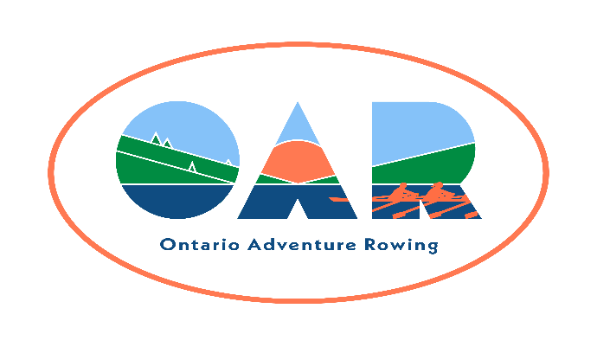
Name of tour and date: Morrisburg Tour
June 8 and 9, 2024
Sponsoring Club : Cornwall Rowing Club
Fee: $100

Name:

RCA Number:

Club Affiliation:

Street Address:

City/Town: Province: Postal Code:

Telephone (home): Telephone (mobile):
E-mail address:

Emergency Contact & Relationship: Telephone:

Assumption of Risk, Liability Waiver, and Conduct Agreement

Assumption of risk: I recognise that the use of the facilities and services of Ontario Adventure Rowing (OAR), and the host club (if any), as well as rowing on open water and related activities, such as but not limited to, loading, rigging and derigging the boats, and launching, landing, and locking through, involve potential risks.

Liability Waiver: I undertake, in my personal capacity and on behalf of those whom I represent or have custody of, and my heirs and assigns, to indemnify and save harmless OAR, its officers, and the host club (if any), their officers and other representatives, and their successors, heirs and assigns, from and against all claims, damages, loss, costs and expenses relating to any injury including death, or loss of, or damage to, my or any third party's property arising out of, or being incidental to my presence at the event.

Public Health Regulations: I certify that I will obey all public safety regulations and protocols. I accept the risk that despite following these regulations, I may contract an infectious disease while participating in an OAR event.

Fitness to row: I am an experienced sculler, and I am fit enough to row 30 km in one day, and I can swim 50 m.

OAR Membership: I am a member of OAR (either individually or through my club).

I agree to the terms of this waiver and provide my signature below as evidence of my agreement.

__________________________________________________________________________
Signature and Date

