Toronto Islands Tour – Sunday July 7, 2024

Come row with us from the Hanlan Boat Club to the Toronto Islands! This is your opportunity to get out on the water and see Toronto from it’s spectacular Harbourfront.
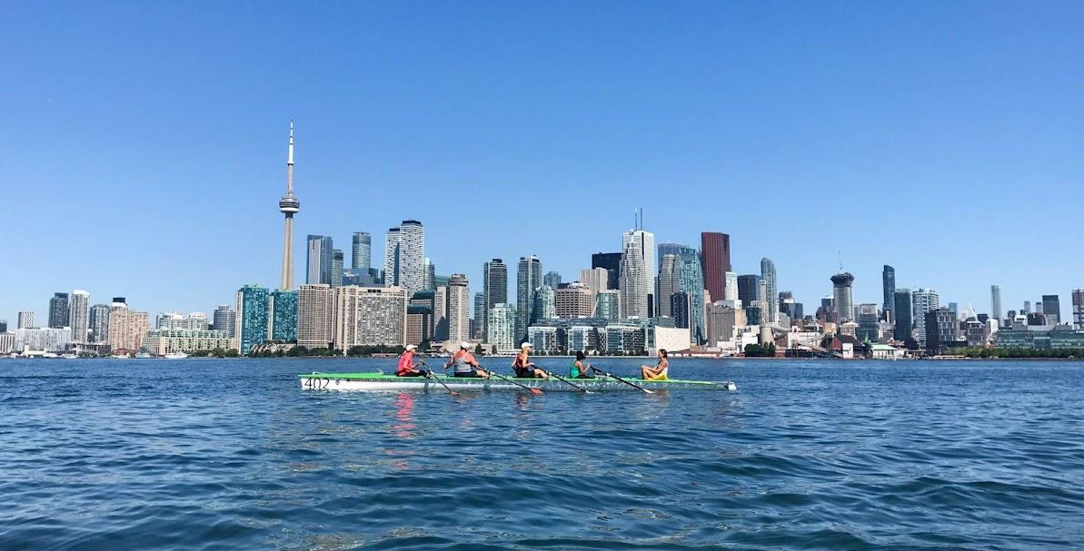
And there’s really good food!
Yes, this is the tour with the legendary BBQ.

We will leave the sheltered waters of the club, row past Cherry Beach, through the Eastern Gap and into the channel between Ward’s and Algonquin Islands. We will wind gently through the islands (there are 15) to our picnic spot on the Long Pond (site of the Dominion Day Regatta).

Itinerary

- 9:00 am – Meet at Hanlan Boat Club, 6 Regatta Road, Toronto - plenty of free parking at the club
- 9:45 am – Leave dock
- Noon – Picnic on the island
- 1:30 pm – Launch for the return to the club
– alternate routes may be possible depending on weather.
- 3:30 – It’s a wrap!

This is a fundraiser for the Hanlan kids camp (Hanlan-YMCA Pedal, Paddle and Rowing Camp) that provides rowing instruction and fun activities for disadvantaged youth in Toronto.

Cost is $60.00 which includes boat, PFD’s, safety boat, and BBQ including water and juice.
Please bring a re-fillable water bottle, rain gear, sunscreen, and an appetite (if you have food allergies or ideology, please let the organizer know when you submit your registration and payment).

This is a very popular tour so don’t delay! We are delighted to welcome you to Hanlan and the Toronto Harbour!

Please send your tour fee, the completed registration form below and any questions to bakertorrance@rogers.com

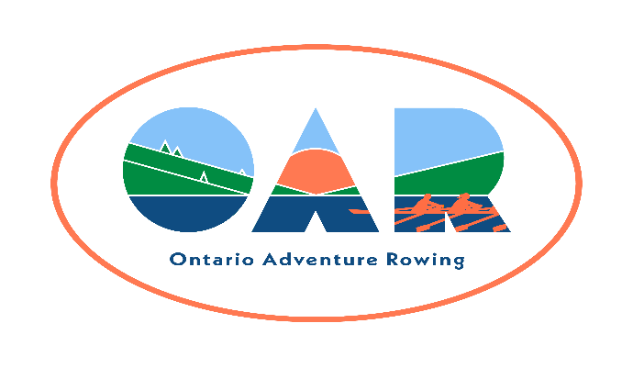
TO Islands – July 7
Sponsoring Club (if any): Hanlan Boat Club

Name:

RCA Number:

Club Affiliation:

Street Address:

City/Town: Province: Postal Code:

Telephone (home): Telephone (mobile):
E-mail address:

Emergency Contact & Relationship: Telephone:

Assumption of Risk, Liability Waiver, and Conduct Agreement

Assumption of risk: I recognise that the use of the facilities and services of Ontario Adventure Rowing (OAR), and the host club (if any), as well as rowing on open water and related activities, such as but not limited to, loading, rigging and derigging the boats, and launching, landing, and locking through, involve potential risks.

Liability Waiver: I undertake, in my personal capacity and on behalf of those whom I represent or have custody of, and my heirs and assigns, to indemnify and save harmless OAR, its officers, and the host club (if any), their officers and other representatives, and their successors, heirs and assigns, from and against all claims, damages, loss, costs and expenses relating to any injury including death, or loss of, or damage to, my or any third party's property arising out of, or being incidental to my presence at the event.

Public Health Regulations: I certify that I will obey all public safety regulations and protocols. I accept the risk that despite following these regulations, I may contract an infectious disease while participating in an OAR event.

Fitness to row: I am an experienced sculler, and I am fit enough to row 30 km in one day, and I can swim 50 m.

OAR Membership: I am a member of OAR (either individually or through my club).

I agree to the terms of this waiver and provide my signature below as evidence of my agreement.

_____________________________________________________________________
Signature and Date

