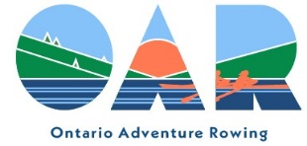
Schedule for 2024
May 11 Banana Belt Don Rowing Club (B. Howe)

May 25 Tay Canal ONEC (J. Robertson/L. Bell)
May 26 Bobs Lake OAR (S. Baker)

Jun 8 Morrisburg East Cornwall RC (K. Donnelly)
Jun 9 Morrisburg West Cornwall RC (K. Donnelly)

Jun 22 Brockville Tour Brockville RC (J. Easton)
Jun 23 1000 Island Tour OAR (J. MacDonald/C. Warn)

Jul 6 Glow Row Hanlan BC (J. Poulin)
Jul 7 Toronto Island Tour Hanlan BC (S. Baker)

Jul 20 Kawartha North OAR (R. Vincent)
Jul 21 Kawartha South OAR (C. Warn)

Jul 29- Aug 1 Lunenburg Lunenburg YC

Aug 17 Nottawasaga Barrie RC (M. Gleben)

Aug 24 Canadian Sculling Marathon ONEC

Sep 4-8 French River OAR (S. Baker, C. Warn)

Sep 14 Georgian Bay OAR (J. Poulin)

Sep 28 TBA TBA

Oct 19 Icicle Chase Ontario Adventure Rowing
Oct 20 Autumn Colours Ontario Adventure Rowing (C. Warn)

