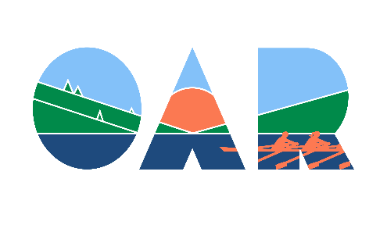

ONTARIO ADVENTURE ROWING ASSOCIATION
ASSOCIATION ONTARIENNE DE RADONEÉ À L’AVIRON

Membership Application for Rowing Clubs
Membership year: April 1 to March 31

The Ontario Adventure Rowing Association partners with Row Ontario to provide and promote distance rowing.
Rowing clubs in good standing with Rowing Canada Aviron and Row Ontario are invited to join OAR. Only Ontario Clubs can join as Affiliated Clubs.
All individual members of Ontario Clubs affiliated with OAR are affiliated members of OAR.

Benefits:
- Your club members get access to 10 to 12 distance events a year co-ordinated by OAR and listed on our website at http://www.adventurerow.ca/ . Your members will not be required to pay a membership fee to join OAR events.
- Your club members will be protected by signed waivers and RCA sanctioning while participating in OAR events
- Your members can give input in the business of the Association.
- Your members get access to regional tours on beautiful waterways/canals as well as international touring.
- Your club can rent OAR equipment for tours or learn-to-scull at discounted prices.

Name of Club ___________________________________________

Club’s financial person: ________________________________ email address__________________________

Contact information of your Club’s distance champion (who will distribute information and promote distance rowing within your club)

Name: _____________________________________________________

Street Address: ______________________________________________

City/Town: ___________________________ Postal Code: ________________

Telephone ___________________________E-mail address:

Please remit completed application and $CDN 120.00 via e-transfer or cheque payable to ‘Ontario Adventure Rowing Association’ to:

treasurer@adventurerow.ca or Ontario Adventure Rowing Association
c/o Diana Watson, Treasurer
1214 Bridge Street,
New Dundee, ON, N0B 2E0

