BOBS LAKE – May 26, 2024
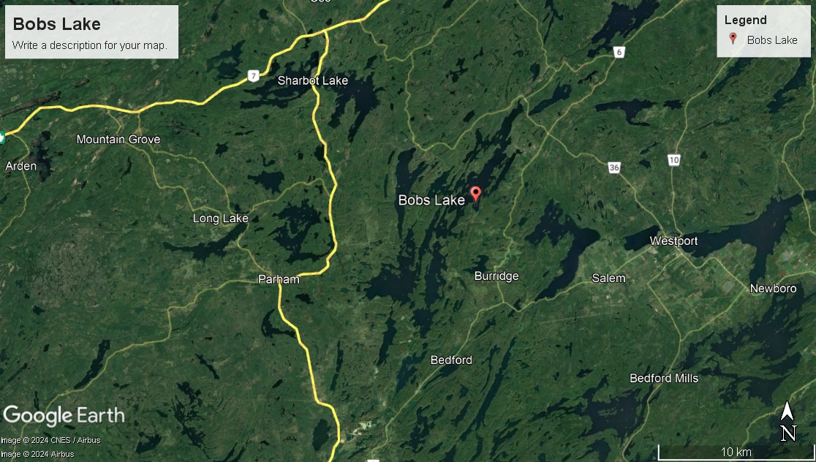

Come and join us on May 26 as OAR explores beautiful Bobs Lake for the first time.

Located in Frontenac County, Bobs Lake is part of the Tay and Rideau watersheds and promises lovely granite outcroppings, marshlands and more than 120 islands.

Time: arrive by 8:30am to unload and rig boats (anticipated finish time 4:30pm– includes derigging and trailer loading time)

Location: Bobs Lake Cottages and Escapes – 75 Burns Lane N, Godfrey K0H 1T0
https://bobslake.com/

Level of difficulty : we plan to row a total of 25-30 kms over the day with a stop mid-way for a picnic lunch
Fee: $85 per person – includes boats and rowing equipment, lunch and adventure.

What to bring: we can supply pfd’s for you but we strongly encourage you to bring your own belt style pfd to wear; refillable water bottle, hat, sunscreen, rain gear

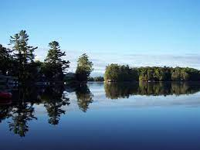
How to register and pay: please fill in the registration form and waiver and email to bakertorrance@rogers.com along with an e-transfer to the same email. (Deadline for registration May 13)

If you have any questions or dietary concerns, please contact Shelagh at bakertorrance@rogers.com. If you are interested in staying at Bobs Lake Cottages and Escapes, please contact them directly.

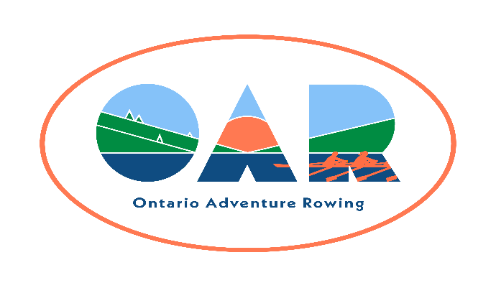
Bobs Lake Tour

Name:

RCA Number:

Club Affiliation:

Street Address:

City/Town: Province: Postal Code:

Telephone (home): Telephone (mobile):
E-mail address:

Emergency Contact & Relationship: Telephone:

Assumption of Risk, Liability Waiver, and Conduct Agreement

Assumption of risk: I recognise that the use of the facilities and services of Ontario Adventure Rowing (OAR), and the host club (if any), as well as rowing on open water and related activities, such as but not limited to, loading, rigging and derigging the boats, and launching, landing, and locking through, involve potential risks.

Liability Waiver: I undertake, in my personal capacity and on behalf of those whom I represent or have custody of, and my heirs and assigns, to indemnify and save harmless OAR, its officers, and the host club (if any), their officers and other representatives, and their successors, heirs and assigns, from and against all claims, damages, loss, costs and expenses relating to any injury including death, or loss of, or damage to, my or any third party's property arising out of, or being incidental to my presence at the event.

Public Health Regulations: I certify that I will obey all public safety regulations and protocols. I accept the risk that despite following these regulations, I may contract an infectious disease while participating in an OAR event.

Fitness to row: I am an experienced sculler, and I’m fit enough to row 30 km in one day, and I can swim 50 m.

OAR Membership: I am a member of OAR (either individually or through my club).

I agree to the terms of this waiver and provide my signature below as evidence of my agreement.

Signature and Date

